TEST PAPER

QUADRATIC EQUATIONS

Q1. Out of a group of swans, 7/2 times the square root of the number are playing on the shore of the tank. The two remaining ones are playing, with amorous fight, in the water. What is the total number of swans?
Q2. The sum of the squares of two positive integers is 208. If the square of the larger number is 18 times the smaller number, find the numbers.
Q3. A plane left 30 minutes later than the schedule time and in order to reach its destination 1500 km away in time it has to increase its speed by 250 km/hr from its usual 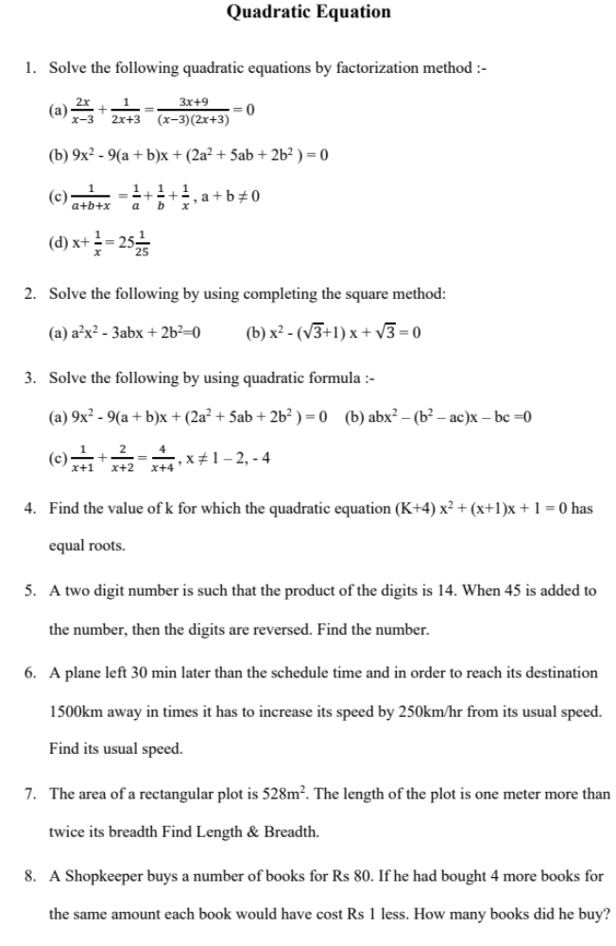speed. Find its usual speed.
Q4. In a flight of 600 km, an aircraft was slowed down due to bad weather. Its average speed for the trip was reduced by 200km/hr and the time of flight increased by 30 minutes. Find the duration of flight.
Q5. Two trains leave a railway station at the same time. The first train travels due west and the second train due north. The first train travels 5km/hr faster than the second train. If after two hours, they are 50 km apart, find the average speed of each train.
Q6. One-fourth of a herd of camels was seen in the forest. Twice the square root of the herd had gone to mountains and the remaining 15 camels were seen on the bank of the river. Find the total number of camels.
Q7. A dealer sells a toy for Rs 24 and gains as much per cent as the cost price of the toy. Find the cost price of the toy.
Q8 .A swimming pool is filled with three pipes with uniform flow. The first two pipes operating simultaneously, fill the pool in the same time during which the pool is filled by the third pipe alone. The second pipe fills the pool five hours faster than the first pipe and four hours slower than the third pipe. Find the time required by each pipe to fill the pool separately.
Q9. If -4 is a root of the quadratic equation x²+px-4=0 and the quadratic equation x²+px+k=0 has equal roots, find the value of k.
Q10. Using quadratic formula, solve the following equation for x:
abx²+(b²-ac)x-bc=0

